

**PROJECT BLH**

**Project Documentation Submitted**

**To the Faculty of School**

**Computing and Information Technologies**

**Under**

**Asia Pacific College**

In partial fulfillment of the Requirements for the Subject

**Structure Systems Analysis and Design (SYSADD1)**

**By:**

**Charles Derek T. Sanvictores**

**John David L. Solomon**

**Jose Eugenio Quesadas**

Project Adviser

**Manuel Sebastian S. Sanchez**

Subject Professor

December 12, 2018

**Table of Contents**

Introduction

Company Profile……………………………………………………..3-7

Abstract………………………………………………………………8

Background of the Problem………………………………………….9

Statement of the Problem……………………………………………10

Objectives……………………………………………………………11

Present System……………………………………………………….12-14

Objectives…………………………………………...……………...15

Scope and Limitation………………………………………………...16

Related Reviews of Literature…………………………………….17-22

GAP………………………………………………………………………....23

Diagrams

Use case Diagram……………………………………………….……24

Use case Full Description…………………………………………….25-31

Event Table………………………………….………………………..32

Activity Diagram…………………………………………………...…33

Context Flow Diagram………………………………………………..34

Object Diagram……………………………………………………….35

Class Diagram………………………………………………………...36

Dataflow Diagram…………………………………………………….37

Entity Relational Diagram…………………………………………….38

Data Dictionary……………………………………………………….35

Sequence Diagram……………………………………………………40-42

Timing Diagram………………………………………………………43

Communication Diagram……………………………………………..44-45

Package Diagram……………………………………………………...46

Deployment Diagram………………………………………………….47

Component Diagram…………………………………………………..48

Interaction Overview Diagram………………………………………..49-51

APPENDICES

Summary of Interview………………………………………………..52-55

Survey form…………………………………………………………..56-59

1. **Introduction**

Company Profile

**Binangonan Lakeview Hospital**

Binangonan Lakeview Hospital Incorporated is a private corporation founded and registered with the Securities and Exchange Commission (SEC) in November 2011. A group of doctors and their friends had a vision to put up a healthcare facility in Binangonan, Rizal that will provide a high qualtiy healthcare service for the community and nearby towns. Sixty (60) percent of the stakeholders are practitioners in the

province who are specialists in their respective fields.

Construction of the hospital building situated in a 2, 158 square meter lot, took almost two (2) years, taking in consideration and strictly following all the Department of Health mandated requirements for a hospital facility.

BLH formally opened as a 30-bed capacity Secondary 2nd Level hospital on October 3, 2014 immediately after the issuance of DOH License to Operate (LTO). After three years, BLH is now an 88-bed capacity and has leveled up to a tertiary hospital.

​

At the moment BLH operates 24 hours, 7 days a week and an accredited partner of Philippine Health Insurance Company (PHIC).

**Mission**

A community of professional healthcare providers advocating competent, ethical and compassionate healing.

**Vision**

We are the Pioneers, the Leaders of Quality healthcare service in the region

**Core Values**

Teamwork  
Integrity  
Professionalism  
Service Excellence  
Social Responsibility

**Services Offered**

Medical and Surgical Clinics

Breast Care Clinic:

Mammogram / Breast Ultrasound

Dental / Panoramic X-ray

Obstetrics and Gynecology Clinics

Pediatric Clinics

ENT Clinic / Hearing Screening Test / Ophtalmology / Cataract Surgery

CT Scan / CT Guided Biopsies

X-ray and Ultrasound

Hemodialysis Center

Pharmacy – 24hr. Service

Tertiary Laboratory – 24 hr. Service

Emergency Medical Services / Ambulance

Physical Rehabilitation Unit

Endoscopy Unit

Oncology Unit

Adult Intensive Care Unit

Neonatal Intensive Care Unit

Outborn Unit

Respiratory Therapy Unit

Memory Screening Test

2D Echo w/ Color Doppler

Diabetes and Nutrition Clinic

Animal Bite Center

Organizational Chart

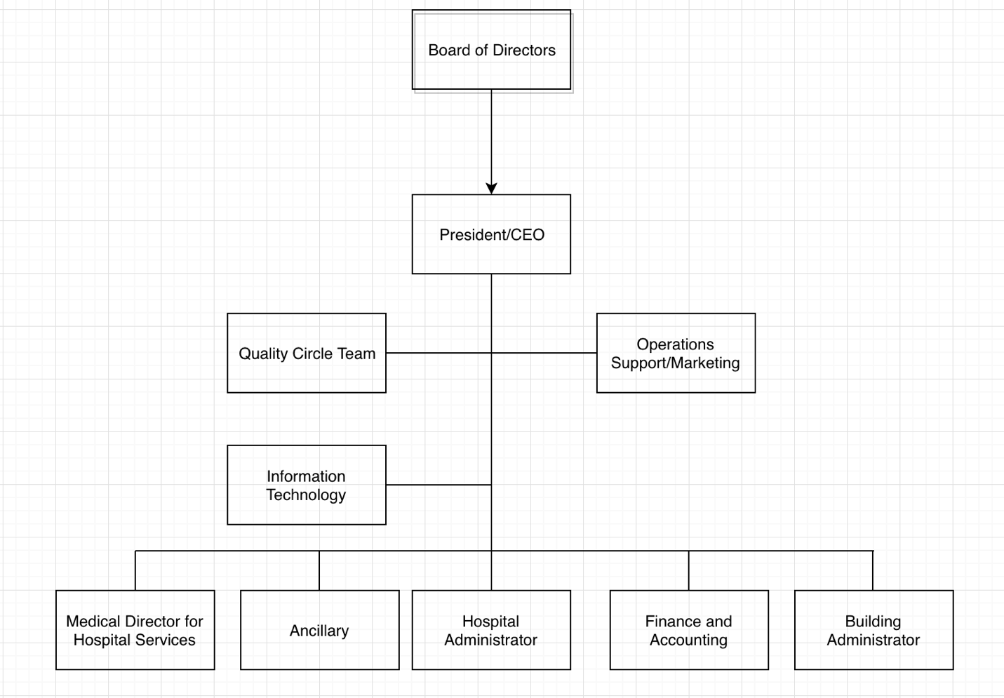

Department / Unit

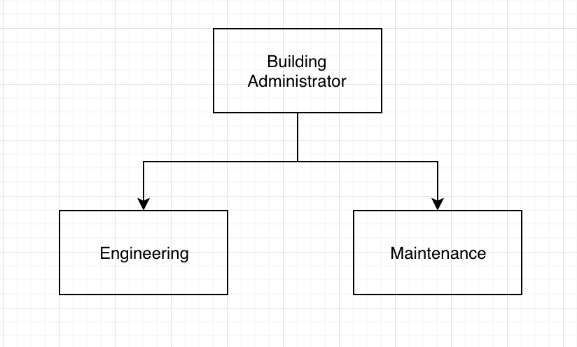

Abstract

The hospital currently has a manual service request system that is not able to cope up with the demands of customers since 2014 based on the data they gathered. As the years go by, they have been looking for an IT personnel that can offer them an automated request system which can resolve some of the hospital’s issues like the inefficiencies, confusions and turndowns of the manual processed services because there are still unnecessary steps and paper dependent process that can only be remove once an automated request system is implemented at ther institution. This project proposal that the researchers are currently doing right now should be able to provide what they need. Our project proposal is based on real data gathered from the hospital.

Background of the Problem

Our client, Binangonan Lakeview Hospital is currently using a traditional manual process service request system, from the filling up of a request form, submitting it to the Building Administrator and getting signed authorization of service request/s from the department supervisors. The current system is inefficient and unreliable at most times especially when it comes to coping with multiple demands from various departments, varying shifts if maintenance personnel and when the service requested requires extended time for completion due to, delayed delivery of supplies, parts, etc. BLH’s current system causes confusion and/or turnover/s of service request because to be able to initiate a job, the maintenance personnel will have to be authorized by a department supervisor.

Statement of the Problem

The proposed system will be addressing the inefficiencies and additional steps and processes of the current manual service request system. There are a lot of service request/s which must be carried out daily and most of the time, even at night. Based on the recorded data by the hospital, since the processes of the current manual service request system is very inefficient, the maintenance department is unable to cope with the demands of various departments, such as for example, Cardiology and Radiology. The two departments were unable to perform their duties because the machines namely the X-ray and ECG are both faulty and/or damaged and where not repaired on time. This issue caused delays and inefficiencies in the delivery of services of the said departments, effectively diminished the trust and confidence of the patients who are in need if the said services. BLH suffers and losses in terms of profits and prominence in offering high quality service whenever an inconvenience happens just because their service request system is still manually processed. The manual system is becoming obsolete and can’t cope with today’s current demand because of many factors like the rapid increase of population, urbanization in the area, new diseases and many more, so, the researchers proposed PROJECT BLH. An automated Service Request Management System capable of meeting today’s demands with ease of usage and efficiency. It only requires a PC with internet connection for the system’s actors namely, Department Supervisor, Admin or Building Admin, and the Maintenance Personnel to be able to communicate to each other without the need of physical interaction and papers. Project BLH is based on Structured System Analysis and Design Method (SSADM).

**PRESENT SYSTEM**

Users of Present System

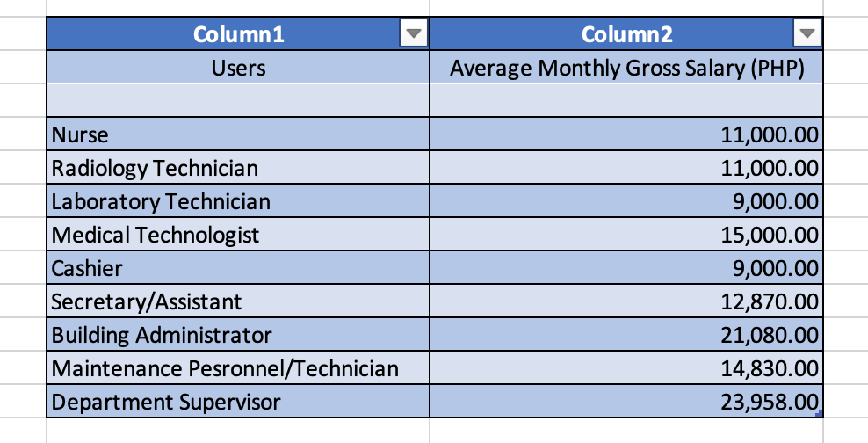

*Note: Some of the given average Monthly Gross Salary were roughly estimated by the company representative of the hospital as this particular subject is confidential.*

**List of Departments and Venues of the Present System**

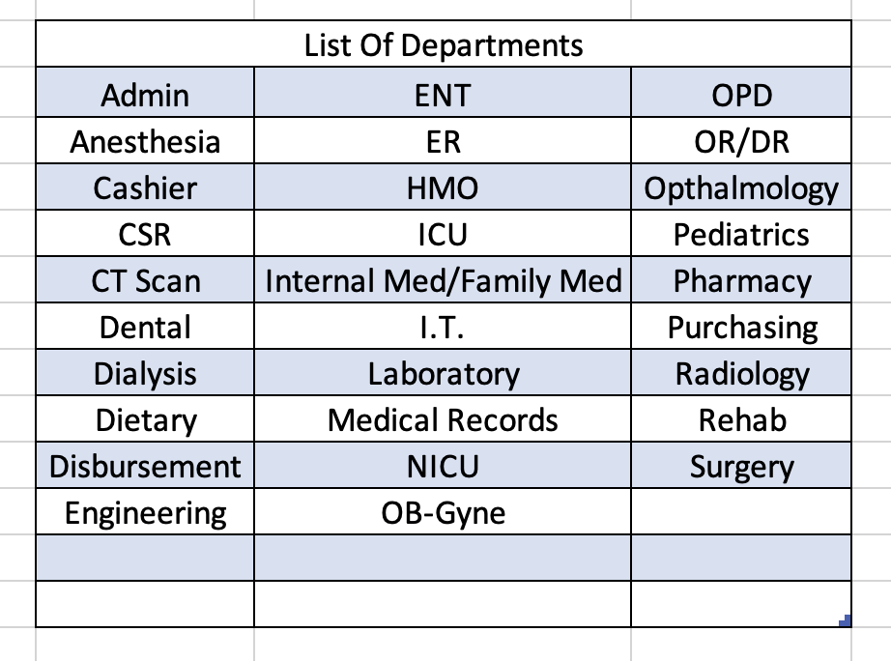

*Note: The departments that are listed are provided by the Admin.*

**Material Cost of the Present System**

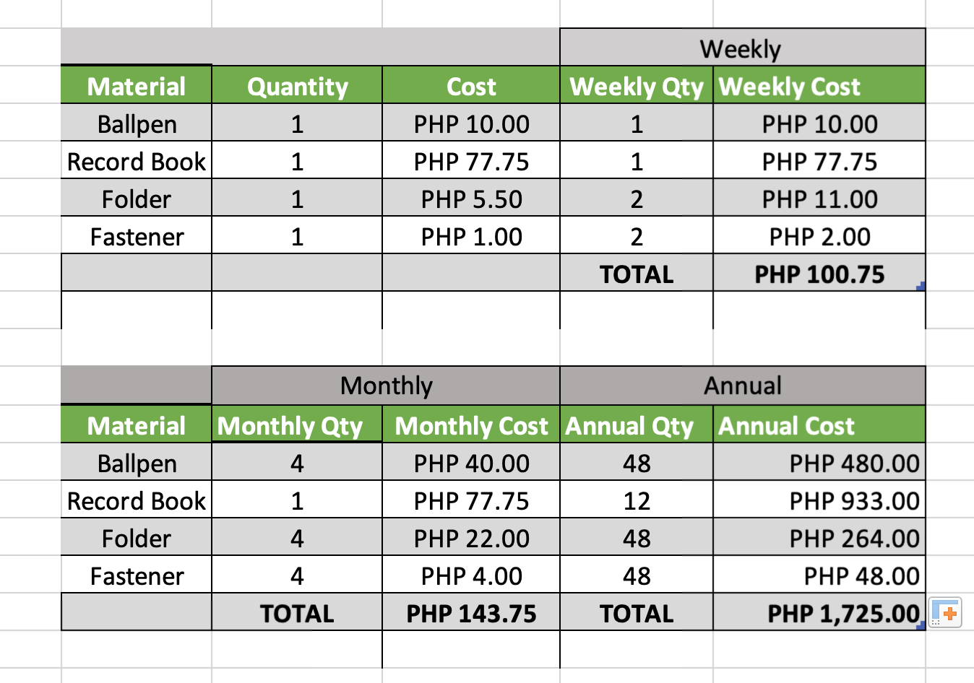

**Form Cost of the Present System**

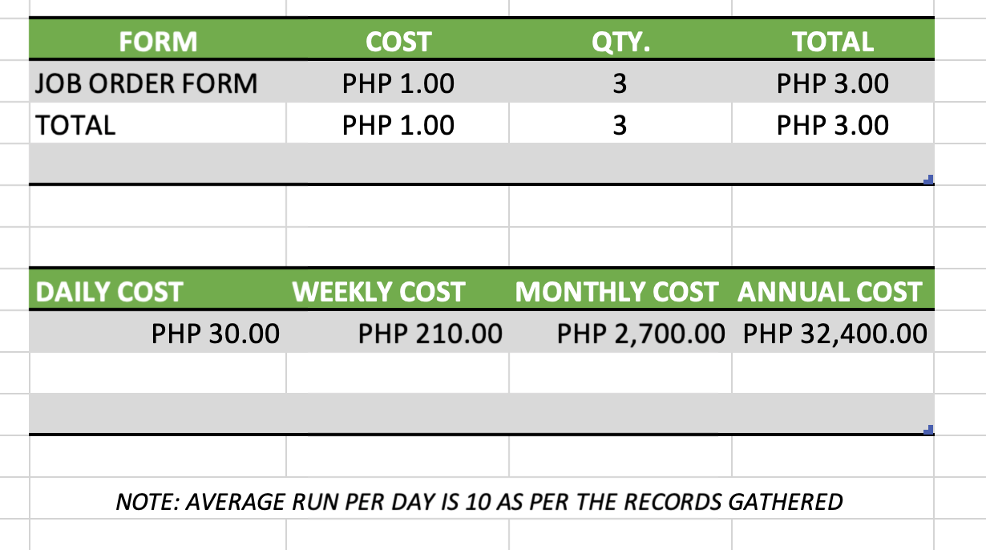

**Objectives**

Main Objectives

The main objectives of BLH is to automate the processing of service request across the 30 departments who uses the current system.

Specific Objectives

* To monitor/track all maintenance service request/s from various departments
* To make the process efficient and faster
* To avoid loss and to cover more jobs needed

**Scope and Limitation**

The Project BLH Service Request Management System shall cover maintenance service request/s.

Based on the data provided by the Hospital, the proposed Service Request Management System will be subject to the following limitations:

There will be 3 types of Requests:

* Replace Request
* Repair Request
* Item Request

There will be 3 users of the System:

* Admin
* Maintenance Personnel
* Department Supervisor

1. **Review of Related Literature**

Introduction:

In this digital age, many companies are adapting automated systems at their workplace, automated systems help lessen paper works and other manual processes that is commonly done with physical interaction, thus, increases the total efficiency and productivity at their workplace. This automated service request system will definitely increase the efficiency and productivity of the services offered at the Binangonan Lakeview Hospital as it helps facilitate their requests management and their personnel all through a software. This service request system can replace the old-fashioned, costly and complicated paper-based methods that decreases the efficiency and productivity of the service management processes of the hospital. There are several systems that can be a reference for this project.

**Service request system by Keily et al. (2017).**

A system allowing a user to communicate with a service provider concerning services includes a user interface panel indicating restroom maintenance services available and communication structure through which a user can select required services and communicate with the service provider.

**Classifications:**

**G06F3/0482** Interaction techniques based on graphical user interfaces [GUI] based on specific properties of the displayed interaction object or a metaphor-based environment, e.g. interaction with desktop elements like windows or icons, or assisted by a cursor&#39;s changing behavior or appearance interaction

with lists of selectable items, e.g. menus

**G06F3/017** Gesture based interaction, e.g. based on a set of recognized hand gestures

**G06F3/0484** Interaction techniques based on graphical user interfaces [GUI] for the control of specific functions or operations, e.g. selecting or manipulating an object or an image, setting a parameter value or

selecting a range

**G06F3/0488** Interaction techniques based on graphical user interfaces [GUI] using specific features provided by the input device, e.g. functions controlled by the rotation of a mouse with dual sensing arrangements, or of the nature of the input device, e.g. tap gestures based on pressure sensed by a digitizer using a touch-screen or digitizer, e.g. input of commands through traced gestures

**G06Q50/12** Hotels or restaurants

**G06F3/04817** Interaction techniques based on graphical user interfaces [GUI] based on specific properties of the displayed interaction object or a metaphor-based environment, e.g. interaction with desktop elements like windows or icons, or assisted by a cursor&#39;s changing behavior or appearance using icons

**Location based service request system by Tendler (2006)**

A wireless phone-based system to accommodate users of wireless phones for providing information as to the location of certain services such as gasoline stations, movie theatres, drug stores, etc., includes the utilization of a GPS receiver and a wireless phone, with the wireless phone adapted to call a predetermined number requesting the desired service and providing the location of the cellular phone. In

one embodiment, the GPS receiver is co-located with the wireless phone in a car, with the wireless phone being carried in a hands-free cradle having a number of service-request buttons, such that depression of a service-request button activates the wireless phone through its bus structure to call a predetermined number and provide the identity of the caller along with the caller&#39;s location. In a further embodiment, a single button, located on the phone or on the hands-free cradle, is utilized to cause the wireless phone to dial a concierge service, in which the concierge service has operators and a database, such that the operator can either direct the caller to whatever service the caller desires or take care of the request, with the operator having been apprised of the location of the wireless phone. This allows the operator to key in the latitude and longitude of the wireless phone and access the database of services both as to the type of service and as to the location of the closest service provider.

**Field of invention:**

This invention relates to a system for helping wireless phone callers, and more particularly, to a wireless phone and GPS-based assistance system.

**Background of the invention:**

As are now common, central dispatch offices are utilized in the provision of roadside assistance through the utilization of an 800 number. Upon dialing a predetermined 800 number from a wireless phone such as a cellular phone, the central dispatch office, through the utilization of its database, can direct the motorist to a variety of different services. For instance, the central dispatch service can provide information as to the nearest towing service, the nearest gas station, the nearest theatre, the nearest drug store, or, in fact, any service of interest to the motorist for which the dispatch office has information in its database. Moreover, with databases utilized at the central dispatch office, it is possible to keep medical records of individuals owning the phone on file so that in the case of a vehicular accident, these files can

be accessed and the appropriate information can be given to rescue authorities. One of the major drawbacks with the respect to such a system is that there is currently no easily implemented way to provide information as to the whereabouts of a vehicle. While, GPS-based systems exist for in-car mapping and other position related applications, such a system is not readily available to every motorist

without an extensive retrofit of the vehicle and corresponding cell sites, making Such systems infrastructure intense. It is in fact a daunting task to be able to provide GPS-based services by providing a GPS receiver in every motor vehicle, much less on a cost effective basis. Thus, it is only with reluctance that automobile manufacturers are providing automobiles with GPS receivers and antennas.

**References:**

Keily et al. (2017). Service request system

Tendler (2006). Location based service request system

1. **Gap Analysis**

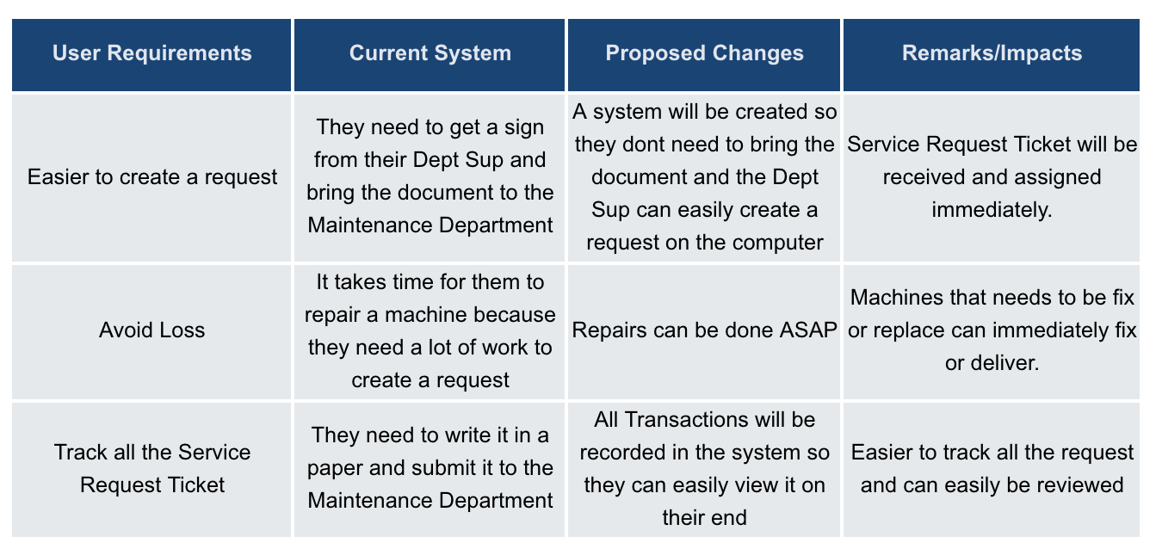

1. **Diagrams**

Use Case Diagram

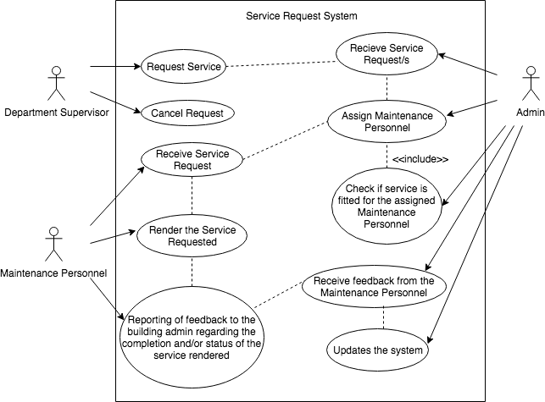

Use Case Full Description

|  |  |  |
| --- | --- | --- |
| Use Case Name: | Maintenance service request | |
| Scenario: | One or many department/s in the hospital is requesting for a maintenance service. | |
| Triggering Event: | Service maintenance | |
| Brief Description: | The department supervisor of each of the hospital's departments may request a maintenance service for a specific or multiple rooms and/or machines. They may also cancel the request if they had a change of thought. | |
| Actor/s | * Department Supervisor * System | |
| Related Use Case: | - | |
| Stakeholders: | * System * Building Admin | |
| Preconditions: | * The department supervisor must have an authorized account * The department supervisor must know all the rooms in his/her department’s jurisdiction. * The department supervisor must know all the machineries’ and the status and conditions of the machines in the rooms within his/her department’s jurisdiction | |
| Post Conditions: | * A request ticket is sent via the system to the building admin’s office. * A maintenance service request notification from the system will appear on the building admin’s station. | |
| Assumptions: | * The request ticket notification will be seen by the building admin. | |
| Flow of Activities: | Department Supervisor | System |
| 1.0 Request for service maintenance | 1.1 Provides notification to the building admin |
| Exception Conditions: | * No request/s * Cancelled request/s * System errors * Internet connectivity issues | |

|  |  |  |
| --- | --- | --- |
| Use Case Name: | Viewing of all service request/s | |
| Scenario: | Building admin has received a request notification from the system. | |
| Triggering Event: | System has provided a notification of a service maintenance request | |
| Brief Description: | The building admin has received a maintenance service request from one or many department supervisor/s that they are in need of of maintenance service | |
| Actor/s | * Building Admin * System | |
| Related Use Case: | Maintenance service request | |
| Stakeholders: | * Building Admin | |
| Preconditions: | * The building admin’s computer must be turned on and has internet connection. * The building admin must have his privileged account logged on. * The building admin must receive a service request notification from the system. | |
| Post Conditions: | * The building admin must acknowledge that he received  the service request notification. * The building admin must proceed to the service maintenance assignment process once the notification is seen and acknowledged. | |
| Assumptions: | * The request is analyzed both by the building admin and the system. | |
| Flow of Activities: | System | Building Admin |
| 2.0 Provide a notification to the building admin | 2.1 Viewing of all service request/s |
| Exception Conditions: | * No request/s * Cancelled request/s * System errors * Internet connectivity issues * Building admin has not yet seen nor acknowledged the maintenance service notification from the system. | |

|  |  |  |
| --- | --- | --- |
| Use Case Name: | Maintenance personnel assignment | |
| Scenario: | System will initialize matching of maintenance personnel based on their skills, availability, previous and/or pending task/s. The building admin will only double check if the system is correct on the matching. | |
| Triggering Event: | System has a database of personnel and will match them based on all details | |
| Brief Description: | The proposed system utilizes a bit of A.I. capability in it, thus the automated matching is based on each of the personnel’s skill’s, availability, attendance and/or previous and/or pending tasks. This will shorten the time of finding who is/are available. The role of the building admin is to check if the system has matched them correctly. The building admin can also change of what the system matched if he wishes. | |
| Actor/s | * Building Admin * System | |
| Related Use Case: | Viewing of all service request/s | |
| Stakeholders: | * System | |
| Preconditions: | * A service request notification must be seen and acknowledged by the building admin. * The system must have a database of all personnel and with details such as their skills, availability, attendance and the statuses of their previous and/or pending task/s. | |
| Post Conditions: | * The building admin must double check if the system has matched correctly | |
| Assumptions: | If the system matched correctly and the building admin has double checked it then the system will proceed to the service maintenance assignment process. | |
| Flow of Activities: | System | Maintenance Personnel |
| 3.0 System will access the database with personnel records and proceeds to the matching process | 3.1 Will double check if system matched correctly |
| Exception Conditions: | * No request/s * Cancelled request/s * System errors * Internet connectivity issues * Confusion/Conflict | |

|  |  |  |
| --- | --- | --- |
| Use Case Name: | Service maintenance assignment | |
| Scenario: | Since the system along with the building has matched the maintenance personnel then the service maintenance assignment will now be assigned to the maintenance personnel. | |
| Triggering Event: | System has provided the service maintenance assignment | |
| Brief Description: | The system has now provided the service maintenance assignment and the maintenance personnel will check them | |
| Actor/s | * Maintenance Personnel * System | |
| Related Use Case: | Maintenance personnel assignment | |
| Stakeholders: | * Department supervisor | |
| Preconditions: | * A dashboard or a PC station must be set up for the use of the maintenance personnel. * Each of the maintenance personnel must have an account that can be used to view the task only assigned specifically to them. | |
| Post Conditions: | * The maintenance personnel must see and acknowledge the task/s that is/are assigned to them. * The maintenance personnel must accept the task. | |
| Assumptions: | * The maintenance personnel has seen and accepted the task and proceeds to do the service itself. | |
| Flow of Activities: | System | Maintenance Personnel |
| 4.0 Provide assigned service maintenance details | 4.1 Do the assigned service maintenance. |
| Exception Conditions: | * No request/s * Cancelled request/s * System errors * Internet connectivity issues * Maintenance personnel has not yet seen nor acknowledged the maintenance service assignment from the system. | |

|  |  |  |
| --- | --- | --- |
| Use Case Name: | Reporting and feedback of the personnel with regards to the service maintenance assignment | |
| Scenario: | The maintenance personnel will provide report and feedback to the system if the service is been completed or if the service is pending because some requires additional time and/or if there are additional delivery time for parts or if he cancels the service. | |
| Triggering Event: | Maintenance Personnel’s end of shift, completion of assigned tasks and cancellation of assigned task. | |
| Brief Description: | After the service has been rendered the maintenance personnel will provide report and feedback to the system flagging the service is done or pending because if the service requires additional time and/or if there is additional delivery time for parts or if the cancellation of the assigned task. | |
| Actor/s | * Maintenance Personnel * System | |
| Related Use Case: | Service maintenance assignment | |
| Stakeholders: | * Department Supervisor * System | |
| Preconditions: | * The maintenance personnel regardless of the status of the completion of his job must flag his job as complete, pending or cancelled. | |
| Post Conditions: | * The department supervisor must receive a notification in the system that a job is finished. | |
| Assumptions: | * The maintenance personnel has finished the service and has provided report and feedback to the system which will be sent to the department supervisor. * The department supervisor has checked his work. | |
| Flow of Activities: | Maintenance Personnel | System |
| 5.0 Provide report and feedback to the system. | 5.1 Records the report and feedback and send a notification to the department supervisor. |
| Exception Conditions: | * No request/s * Cancelled request/s * System errors * Internet connectivity issues * Maintenance personnel has cancelled and/or chose not do it anymore/yet. | |

|  |  |  |
| --- | --- | --- |
| Use Case Name: | Reviewing of the service rendered by maintenance personnel | |
| Scenario: | After the submission of the report and feedback of completion of the service rendered by the maintenance personnel, the department supervisor will check their work after. | |
| Triggering Event: | Maintenance personnel have submitted a report and provide feedback about the service maintenance assignment | |
| Brief Description: |  | |
| Actor/s | * Department Supervisor * System | |
| Related Use Case: | Reporting and feedback of the personnel with regards to the service maintenance assignment | |
| Stakeholders: | * System | |
| Preconditions: | * The department supervisor must receive a notification in the system that the maintenance personnel has flagged his job as completed. | |
| Post Conditions: | * The department supervisor must review the service rendered by the maintenance personnel. | |
| Assumptions: | * The department supervisor has reviewed the service rendered by the maintenance personnel, thus that request ticket can now be officially closed. | |
| Flow of Activities: | Department Supervisor | System |
| 6.0 Review the service rendered by the personnel and close the ticket | 6.1 Request Ticket Closure |
| Exception Conditions: | * No request/s * Cancelled request/s * System errors * Internet connectivity issues * Department supervisor has not checked the service rendered. * Department supervisor has not closed the ticket. | |

|  |  |  |
| --- | --- | --- |
| Use Case Name: | Creation of reports | |
| Scenario: | The system will collect all of the feedback and reports from all actors on a daily basis and so on. | |
| Triggering Event: | Collection of all feedbacks and reports from all actors. | |
| Brief Description: | Whenever an action is done that involves the system, the system will collect all the data and store them for future use and decision-making. | |
| Actor/s | * Building Admin * System | |
| Related Use Case: | All Use Cases | |
| Stakeholders: | * System * All Actors | |
| Preconditions: | * The system itself must be used. | |
| Post Conditions: |  | |
| Assumptions: | * The continuous collection of data will provide data analysis for future decision-making. | |
| Flow of Activities: | System | System |
| 7.0 Collect all feedbacks and reports on a daily basis and so on. | 7.1 Continuous collection of data for analysis and future decisions. |
| Exception Conditions: | * No request/s * Cancelled request/s * System errors * Internet connectivity issues * None or very few feedbacks and reports. * Not using the system. | |

Events Table

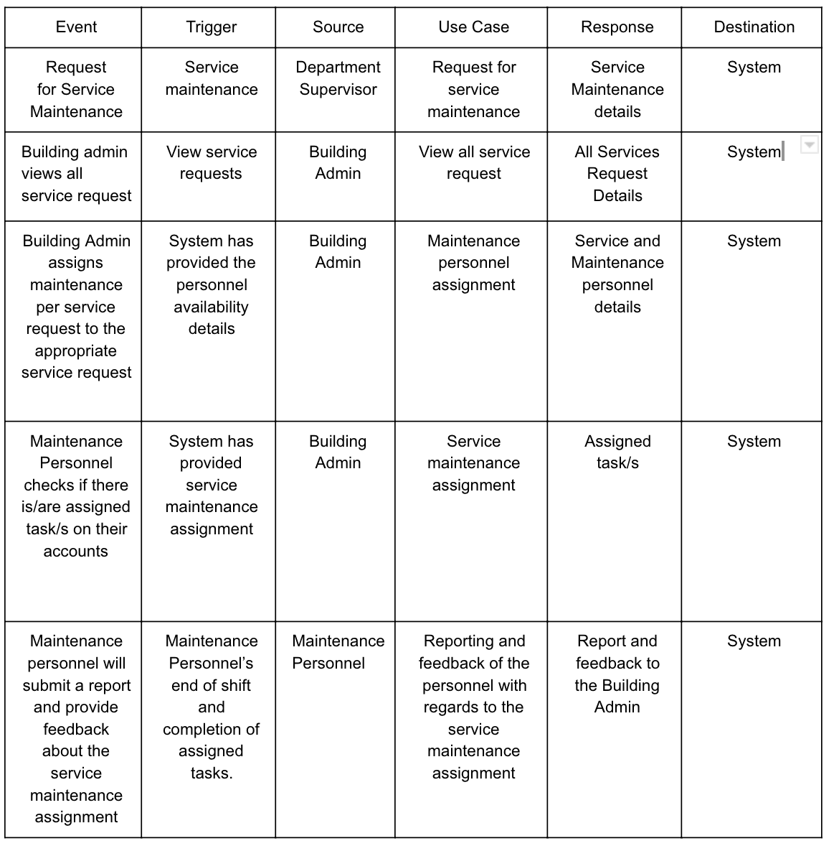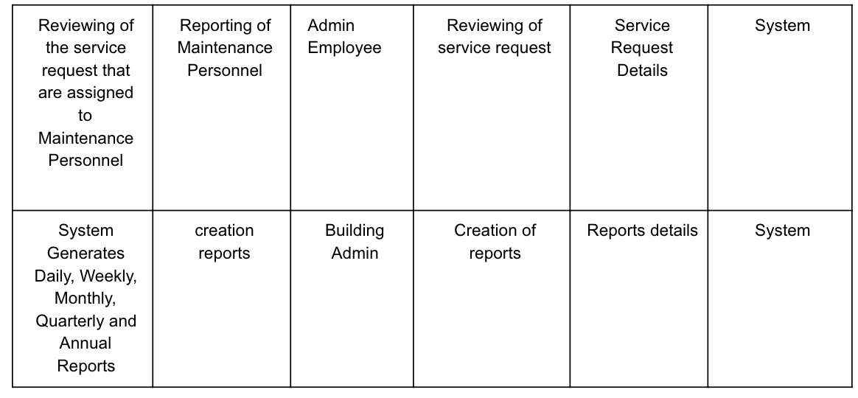

Activity Diagram

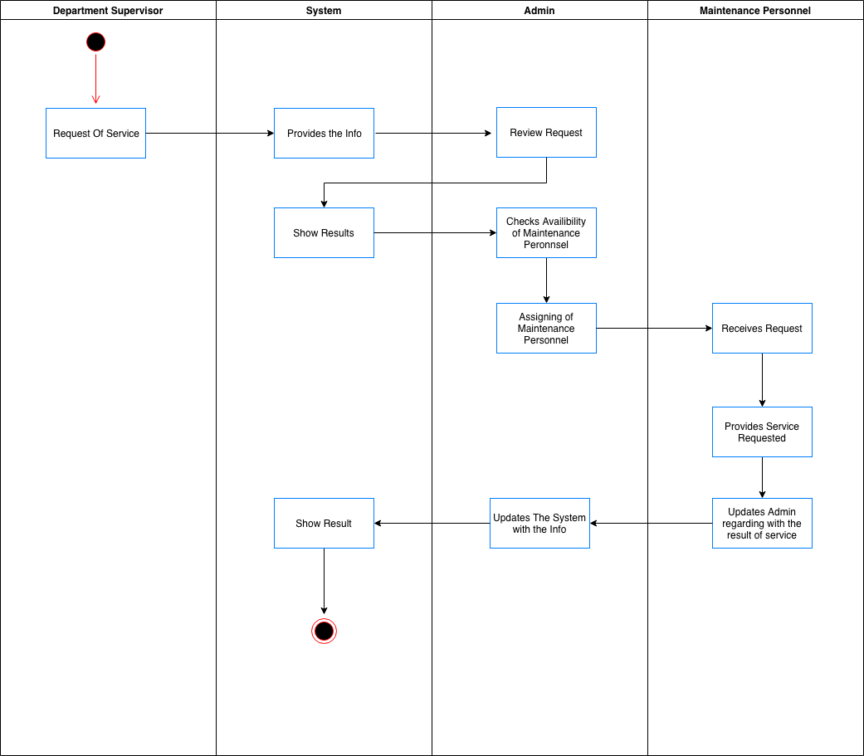

Context Flow Diagram

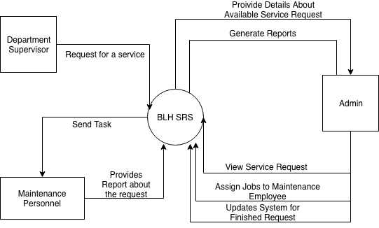

Object Diagram

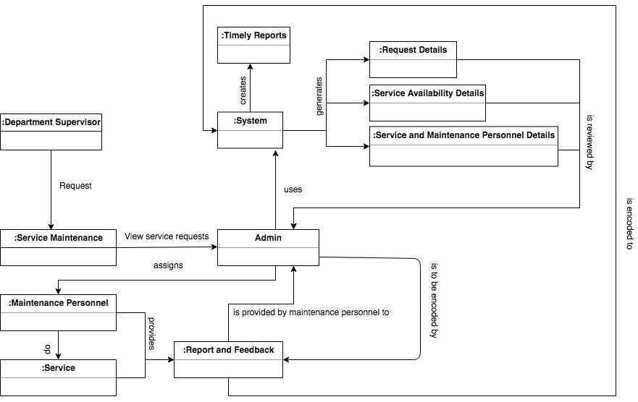

Class Diagram

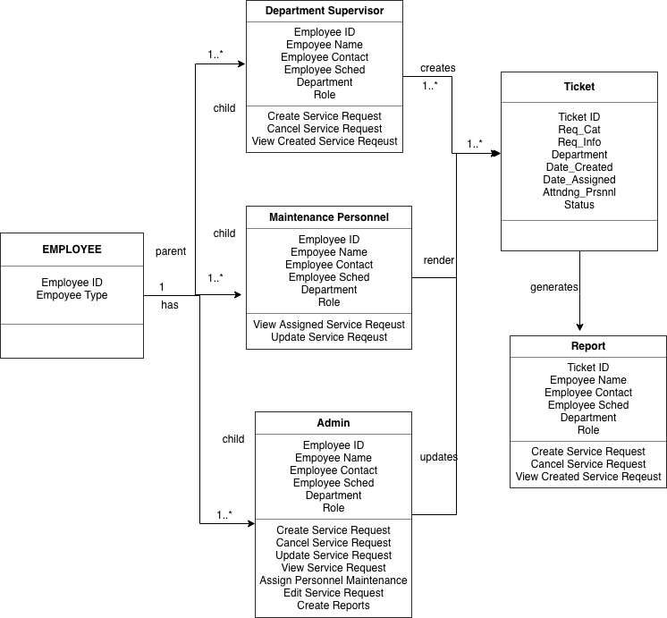

Data Flow Diagram

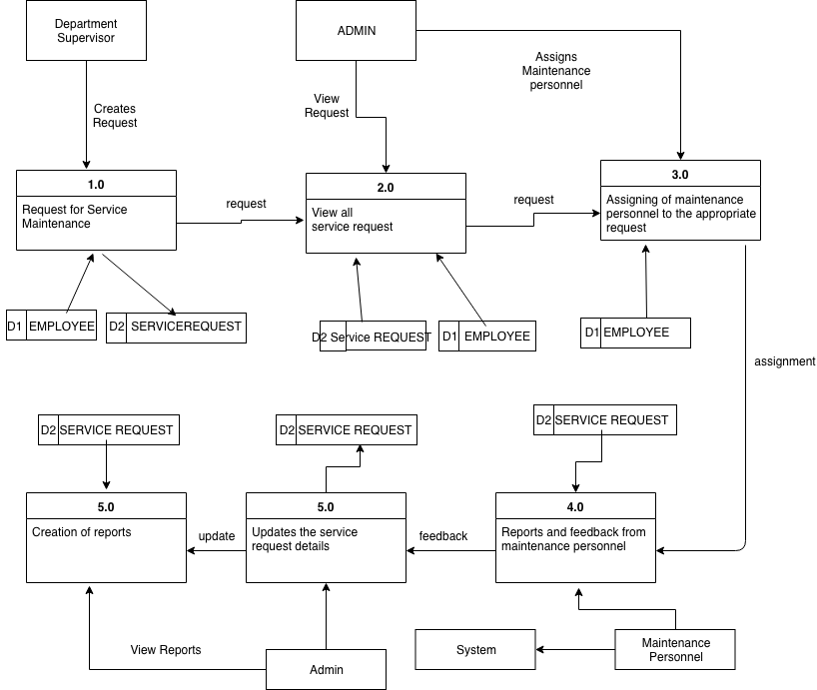

ERD

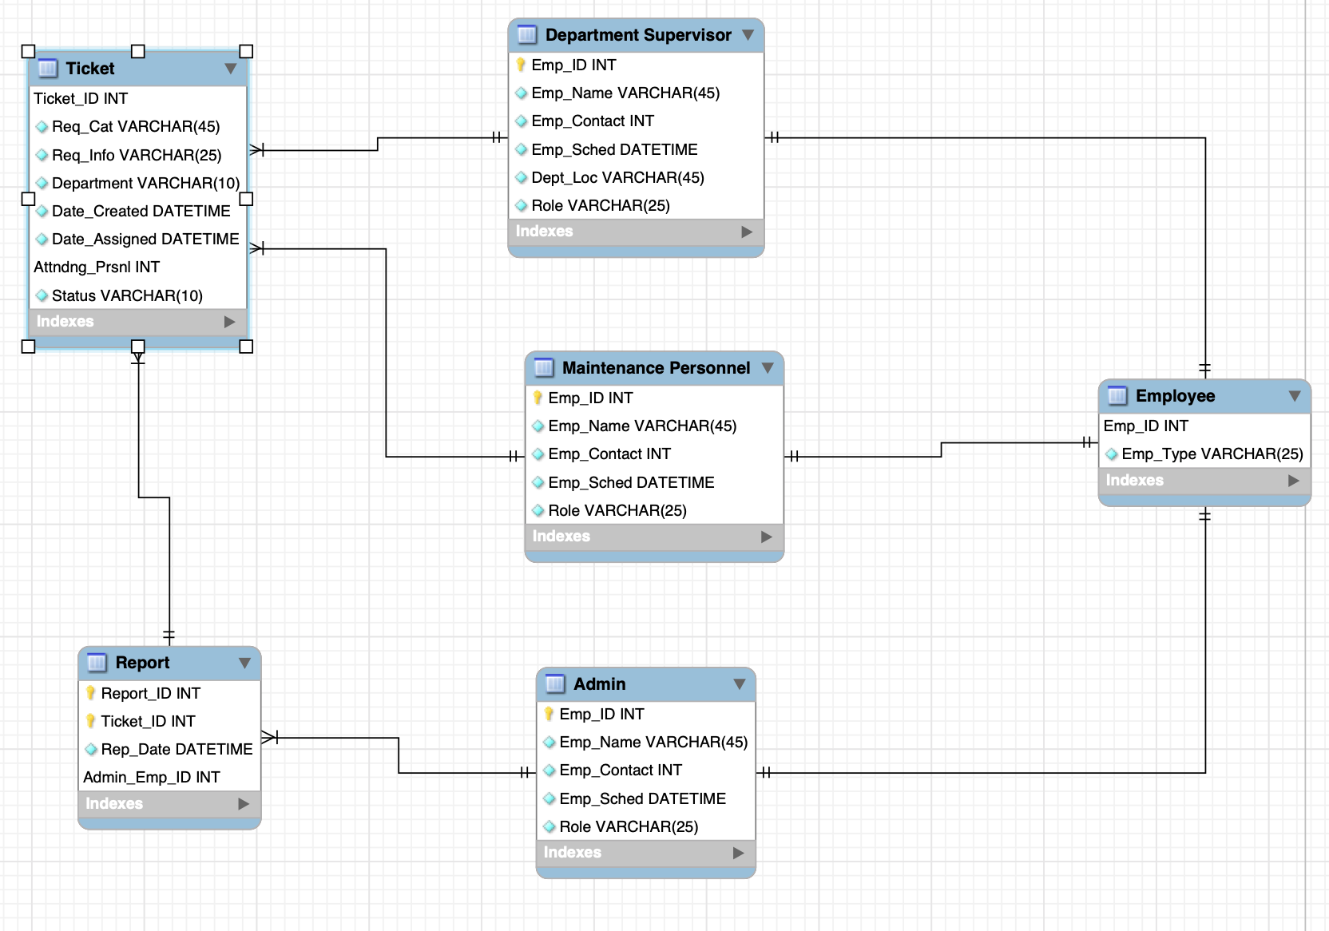

Data Dictionary

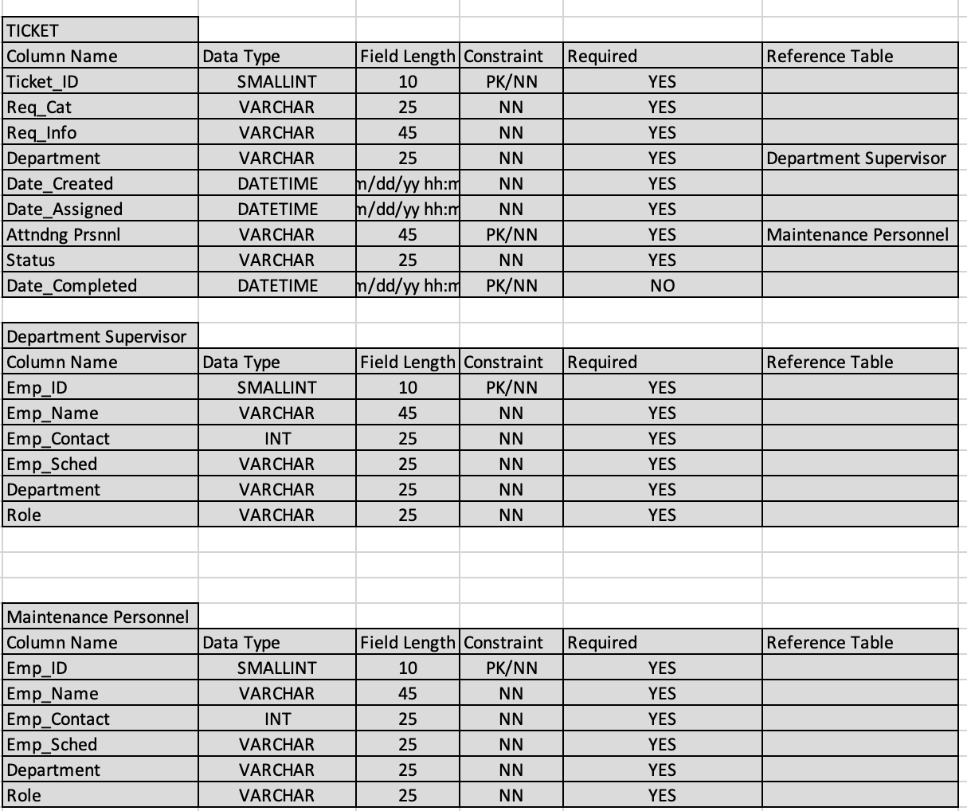

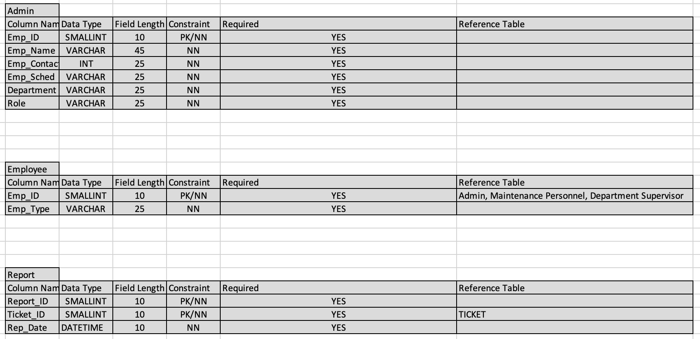

Sequence Diagram

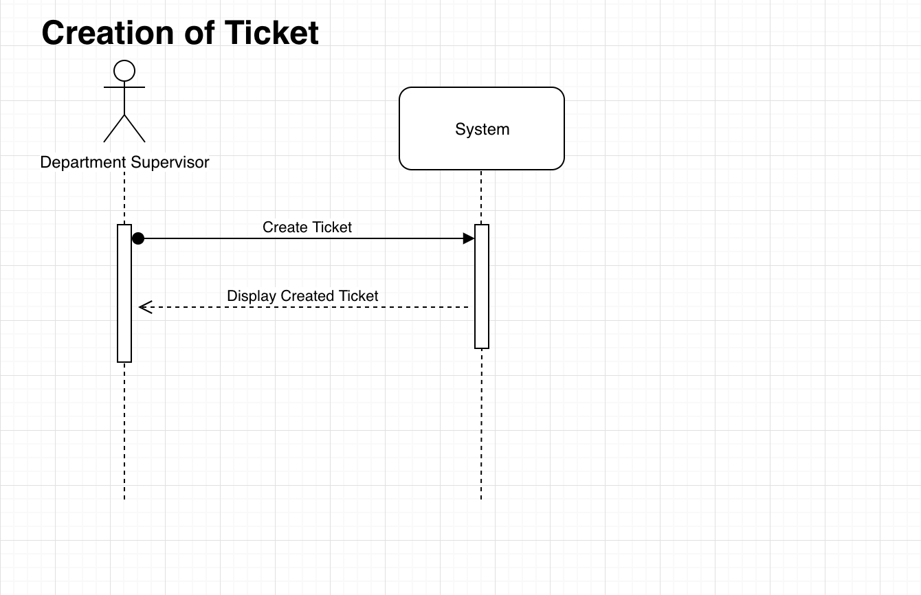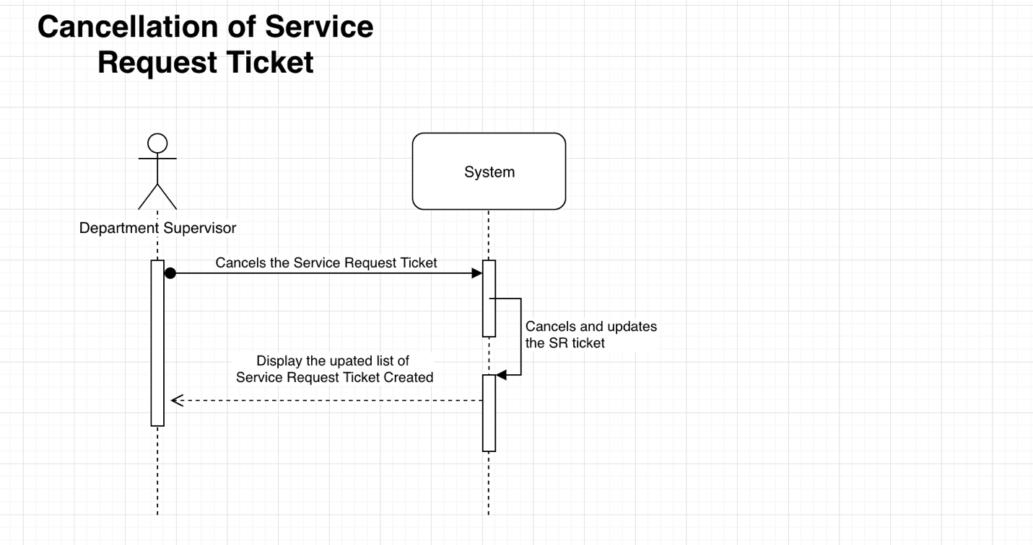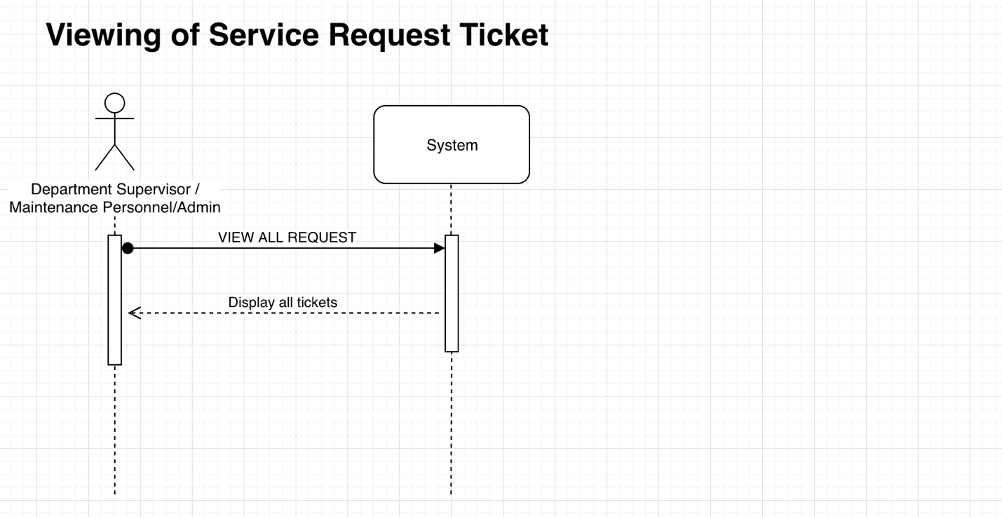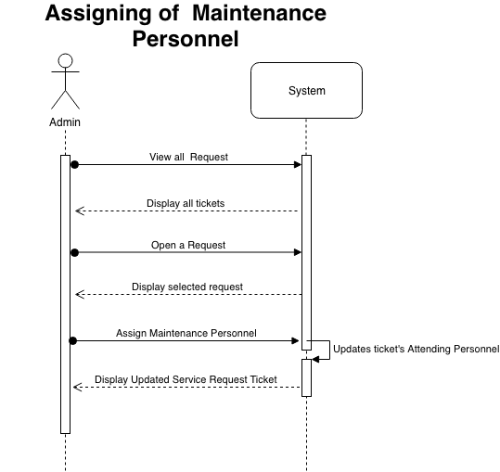

State Diagram

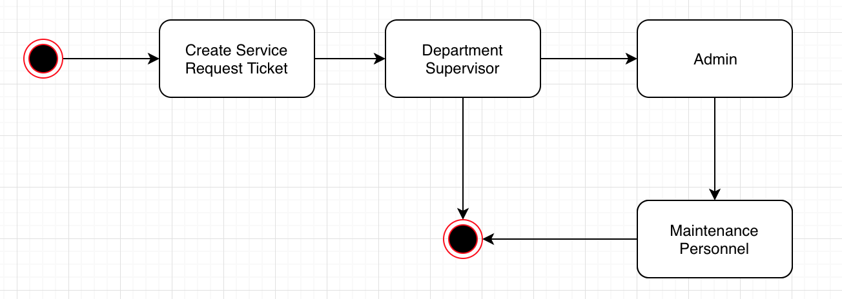

Timing Diagram

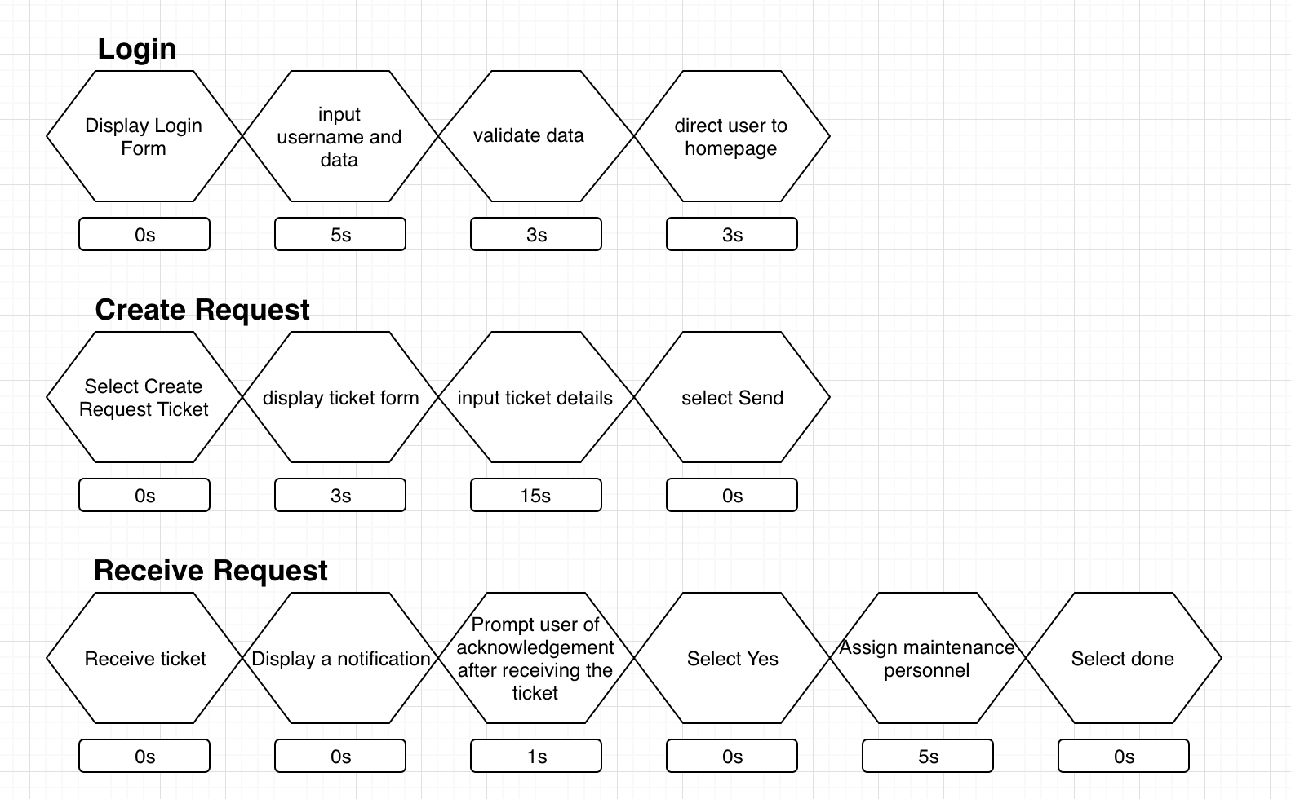

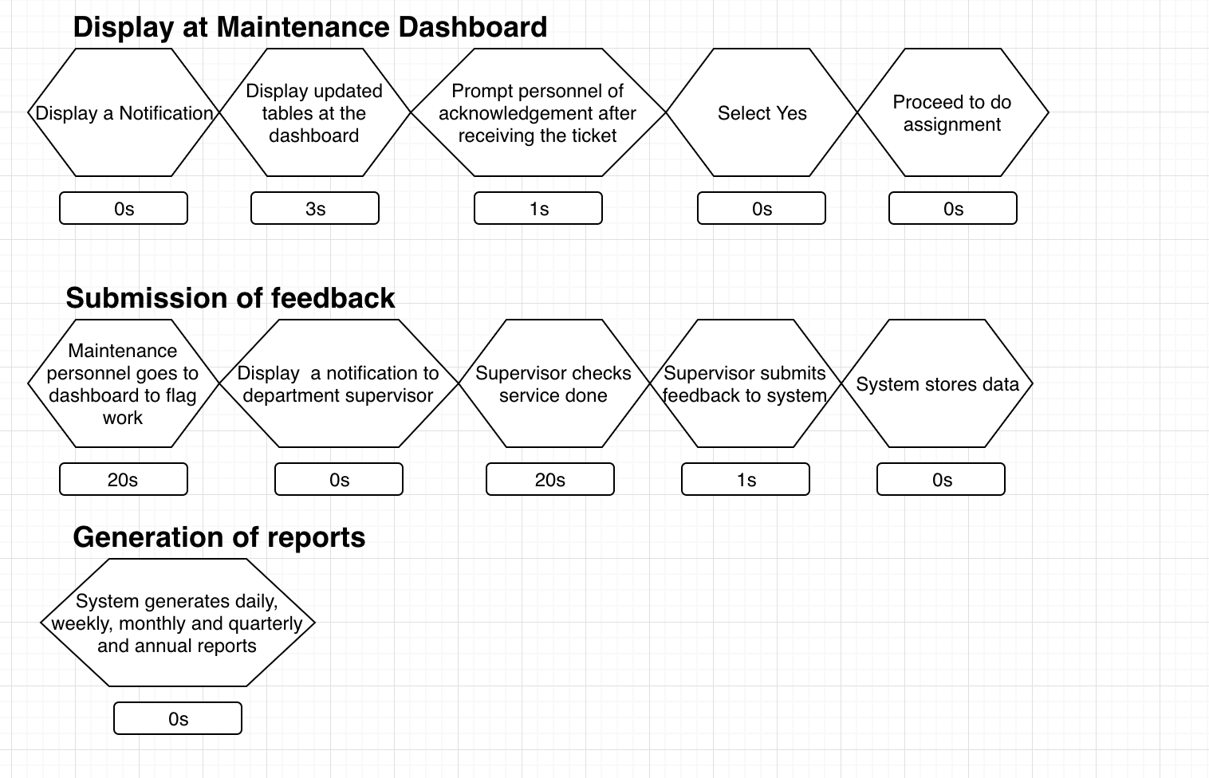

Communication Diagram

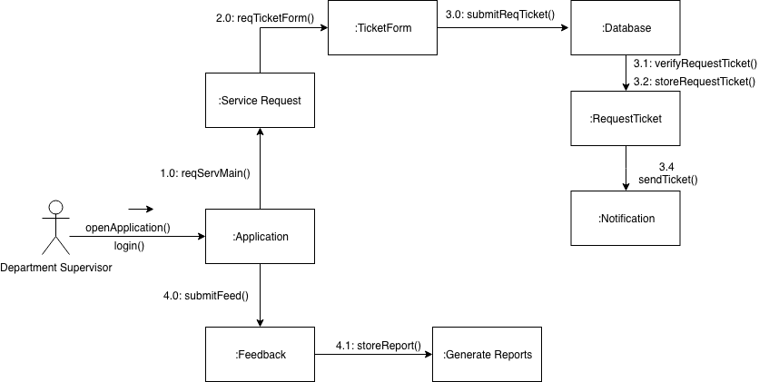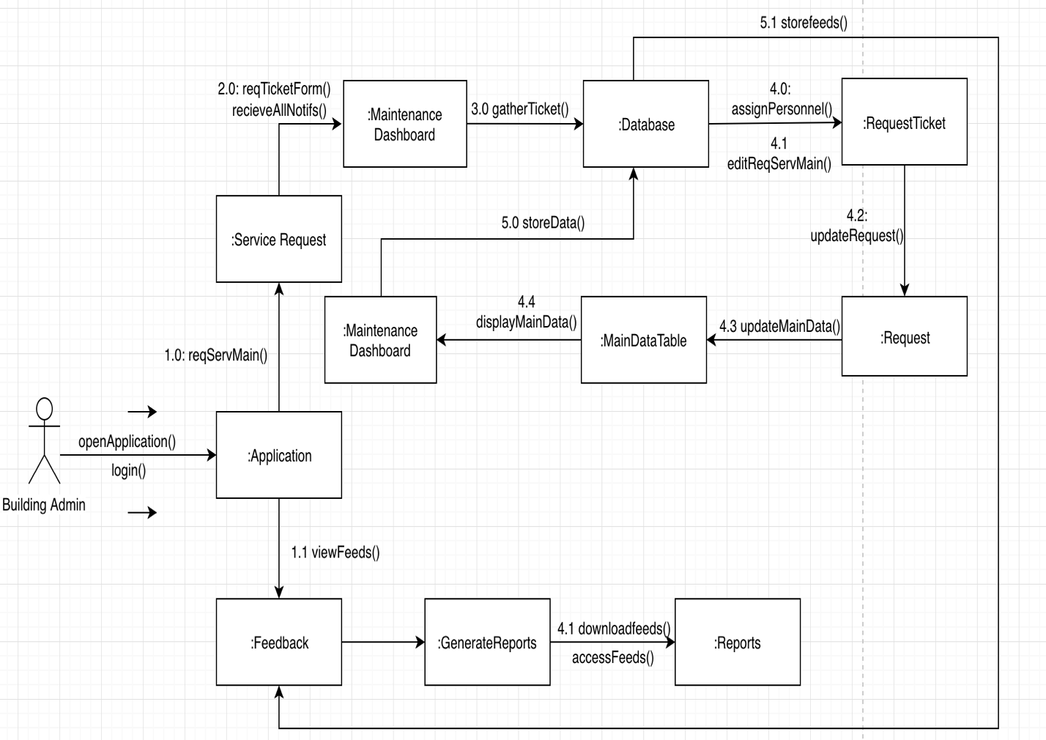

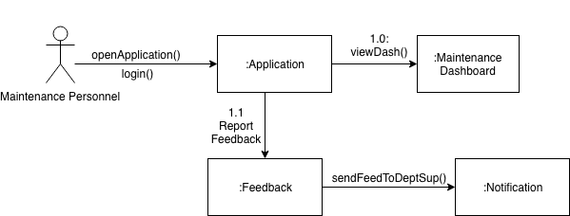

Package Diagram

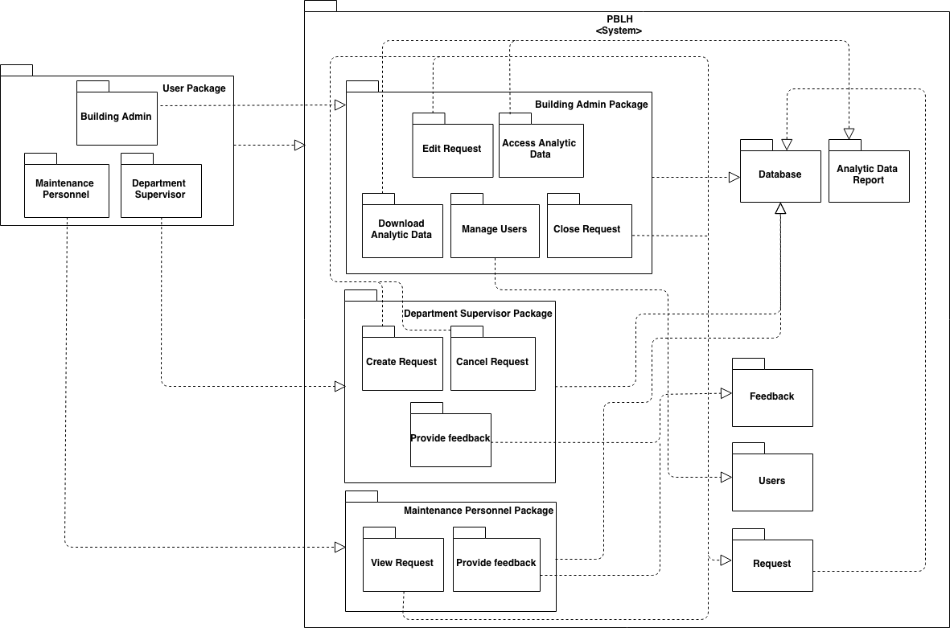

Deployment Diagram

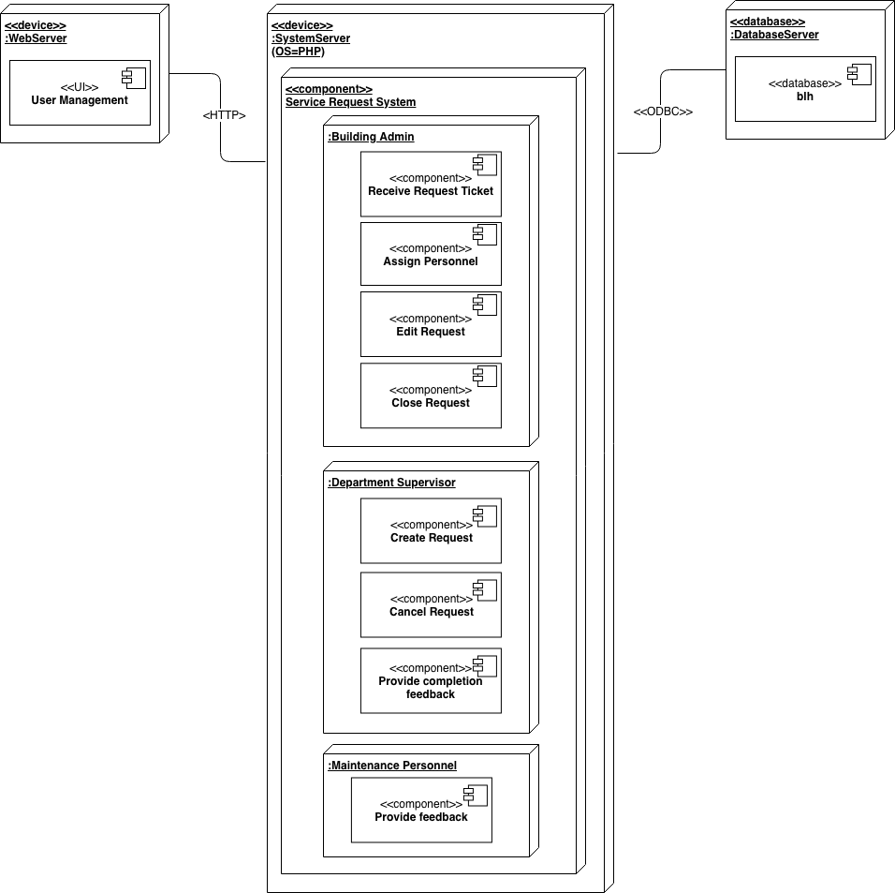

Component Diagram

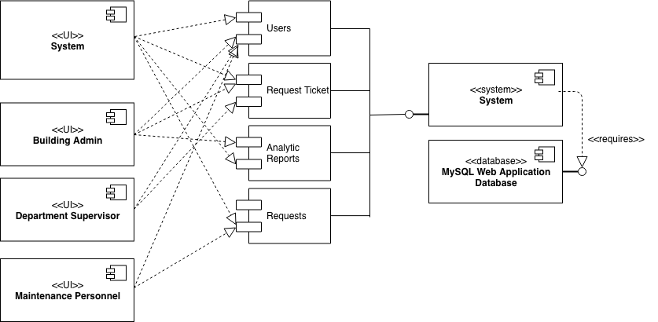

Interaction Overview Diagram

Creation Of Ticket

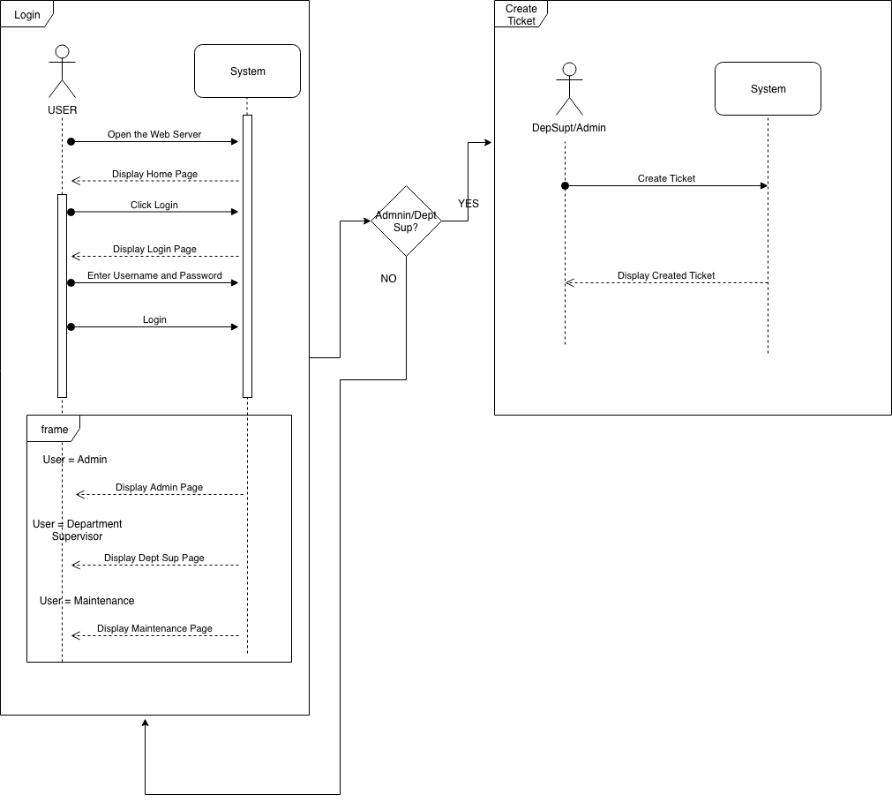

Cancellation of Ticket

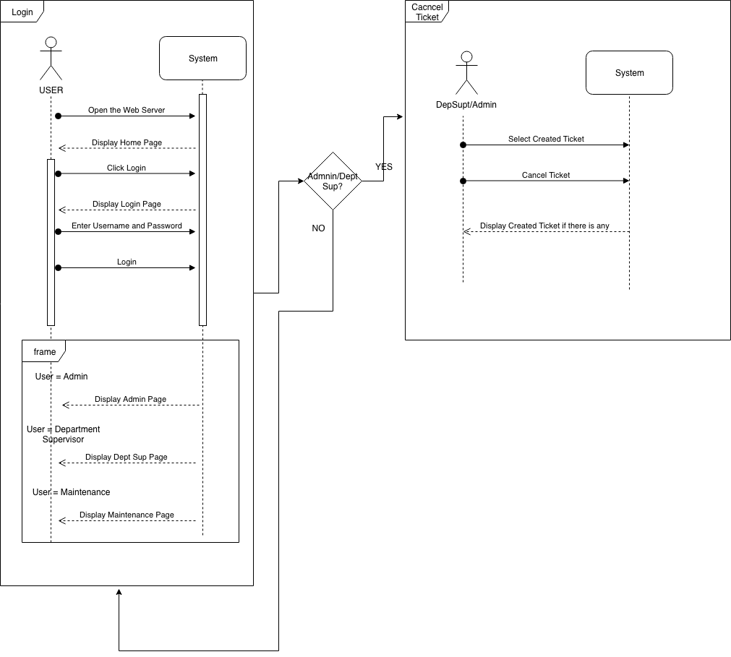

Assigning of Ticket

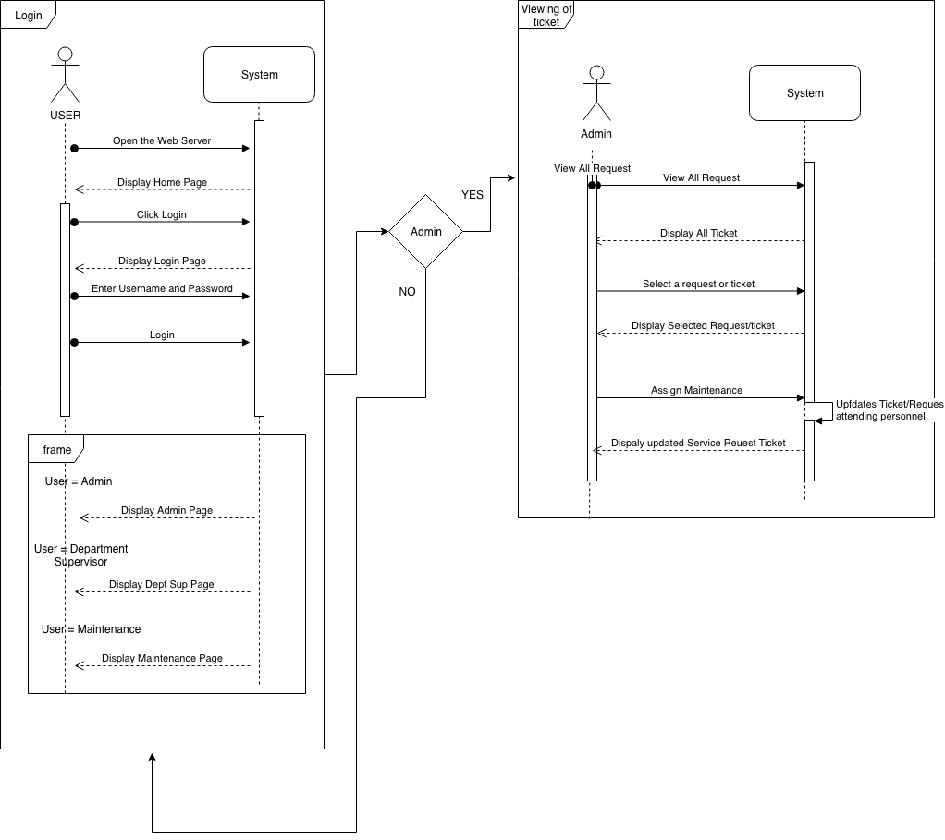

**SUMMARY OF INTERVIEW**

Summary of Q&A/Interview

October 9, 2018 – November 26, 2018

**Legend:**

I = Interviewer

A = Admin

**I – Hi sir, as what you’ve said last week when I asked if there is something that we CS students from APC can help or do for the hospital and will serve as our project. “Diretso nyo po sinabi na may problem po kayo regarding Job Order Request or Service Request Management.”**

**Can we ask the whole process of the Job Order Request or the Service Request Management.**

A – So there are 4 types of user.

* Admin
* Department Supervisor
* Maintenance Personnel
* Employee such as (Nurse, Radiology Technician, Medical Technologist, Laboratory Technician, Cashier, Secretary/Assistant.

And 3 types of request.

* Repair
* Replace
* Item Request

The Employee or requestor needs to print and fill-up 3 copies of Job Order Request form. One copy for their record, one copy for us and one copy for the Maintenance.

Once the form is filled-up by the requestor, they will bring it to the Department Supervisor for it to be signed. Then once the forms are signed, they will bring the completed form to our office.

We will check and analyze the request, for us to know the right Maintenance Employee to assign based on the request. “If end of shift na ni Maintenance and hindi pa nya tapos yung job, the job will be endorsed to the next attending Maintenance”.

**I - What are the main challenges or common factors of the problem regarding with the recent system?**

Based on the feedbacks that we’ve got, there are 4 factors that causes delay of the Job Order request.

* Slow Processing of signatories
* Total distance travelled to maintenance department
* Not following procedures
* Insufficient skills of employees to repair equipment

**I – Why do you think so? Do you happen to identify the problems that is causing it?**

A – Sometimes they are not following the proper procedure like incomplete forms that’s why the request got rejected.

“Hindi naman ganon kalaki ang bawat department, hindi din naman din sila ganon kadame magrequest per department, pero minsan sa dame ng department na meron kame tulad ngayon meron kame almost 30. Minsan nagkakataon na walang available na gagawa. Minsan yung available na Maintenance hindi suitable para dun sa job kaya kaylangan maghintay. Minsan din kasi kulang-kulang yung nilalagay nila sa form kaya narereject. Fully equipped ng CCTV yung hospital kaya nakikita din namin if baka dahil hindi inaaksyunan ng Maintenance Personnel yung request. So far hindi naman yun yung main issue. May mga need irepair minsan na kaylangan ng 3rd party technician specially machines na inaabot ng days bago matapos dahil sa tagal din dumating ng gagawa.”

**I = So what are the things that you’ve done to minimize the problem or what are your solutions?**

A = What we are doing is, training the maintenance personnel for them to handle different types of jobs. “ Sa forms naman we told them to comply para iwas reject and make sure na complete yung form, minsan kung wala talaga magsign ng form, yung pinakamalapit na department supervisor nalang pipirma at magverify ng request.”

**I = As what you have said, the problem is the availability of the Maintenance Personnel. Why not hire more Maintenance Employee?**

A = Budget is limited. “Kaya ang ginagawa ko as an Engineer, tinatrain namin sila para pwede sila maassign sa ibang job. Tho they are working as a team and yung iba nagtatanong dun sa marunong para matuto sila kung pano ba gagawin.”

**I = Is it not dangerous to assign them to a job that they are not specialized in?**

A = “Hindi naman, kasi halos lahat naman sila may mga background na din sa ibat ibang job, madali din sila nagkakatintindihan ng ibang maintenance personnel.”

**SURVEY RESULT**

Company Survey

